**Venkata Srinivas Kompally (NUID: 002137855)**

**Program Structures & Algorithms**

**Fall 2021**

**Assignment No. 1**

* **Task :**

Imagine a drunken man who, starting out leaning against a lamp post in the middle of an open space, takes a series of steps of the same length: 1 meter. The direction of these steps is randomly chosen from North, South, East or West. **After n steps, how far (d), generally speaking, is the man from the lamp post?** Note that d is the Euclidean distance of the man from the lamp-post.

It turns out that there is a relationship between d and n which is typically applicable to many different types of stochastic (randomized) experiments. Your task is to implement the code for the experiment and, most importantly, to **deduce the relationship**.

* Conclusion about the relationship between d and n
* Evidence to support that relationship
* Code
* Screenshot of unit tests
* **Relationship Conclusion:**

$d ≈ √n$

**d = Euclidean Distance**

**n = Number of Steps**

* **Evidence to support the conclusion:**

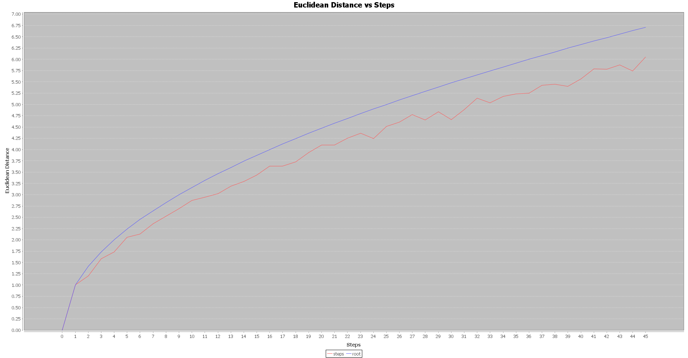

1. **Output (Snapshot of Code output in the terminal):**

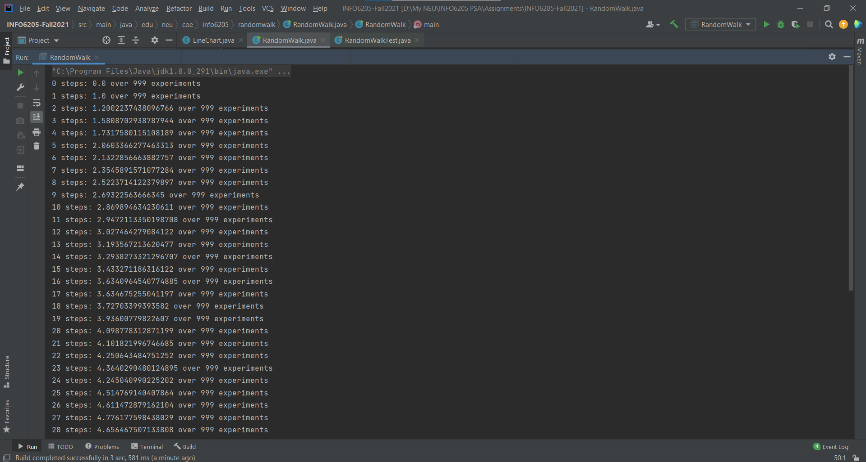

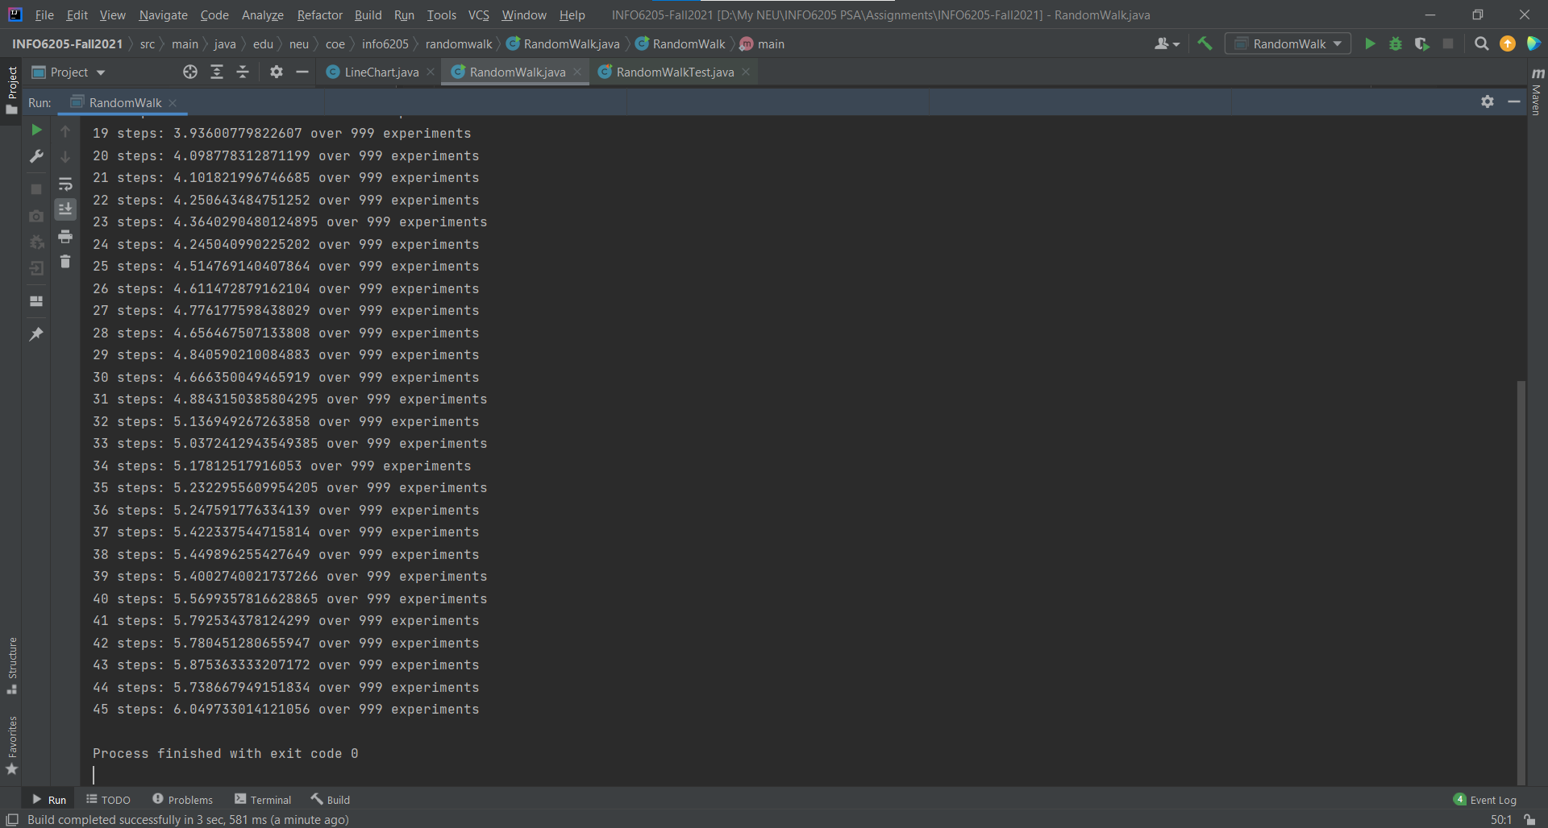

1. **Graphical Representation(Observations from experiments should be tabulated and analyzed by plotting graphs(usually in excel) to arrive on the relationship conclusion)**

* I’ve plotted graph using JFreeChart framework, I did not use excel separately to store my *n* and *d* values, instead I computed and analyzed the relationship in the java program itself. There was a lot errors in the distance, and I was able to conclude that it is somewhere near root(n).

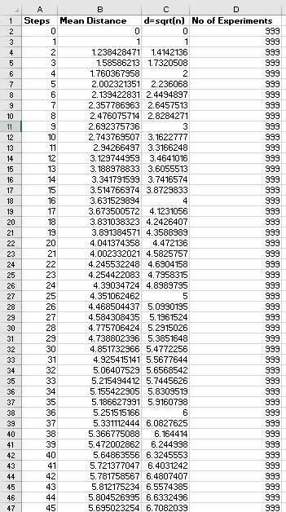

* **Unit tests result:(Snapshot of successful unit test run)**

